**Microprocessor and Computer Architecture**

**UE20CS252**

**4th Semester, Academic Year 2021-22**

Date: 07/02/2022

|  |  |  |
| --- | --- | --- |
| Name: VISHWAS M | SRN:  PES2UG20CS390 | Section: F |

Week#____4_______ Program Number: ____1___

Title of the Program

**Write a program in ARM7TDMI-ISA to find GCD of two numbers.**

1. **Assume operands to be in the CPU registers**

**i)**

**MOV R1,#86**

**MOV R2,#92**

**LOOP: CMP R1,R2**

**SUBGT R1,R1,R2**

**SUBLT R2,R2,R1**

**BNE LOOP**

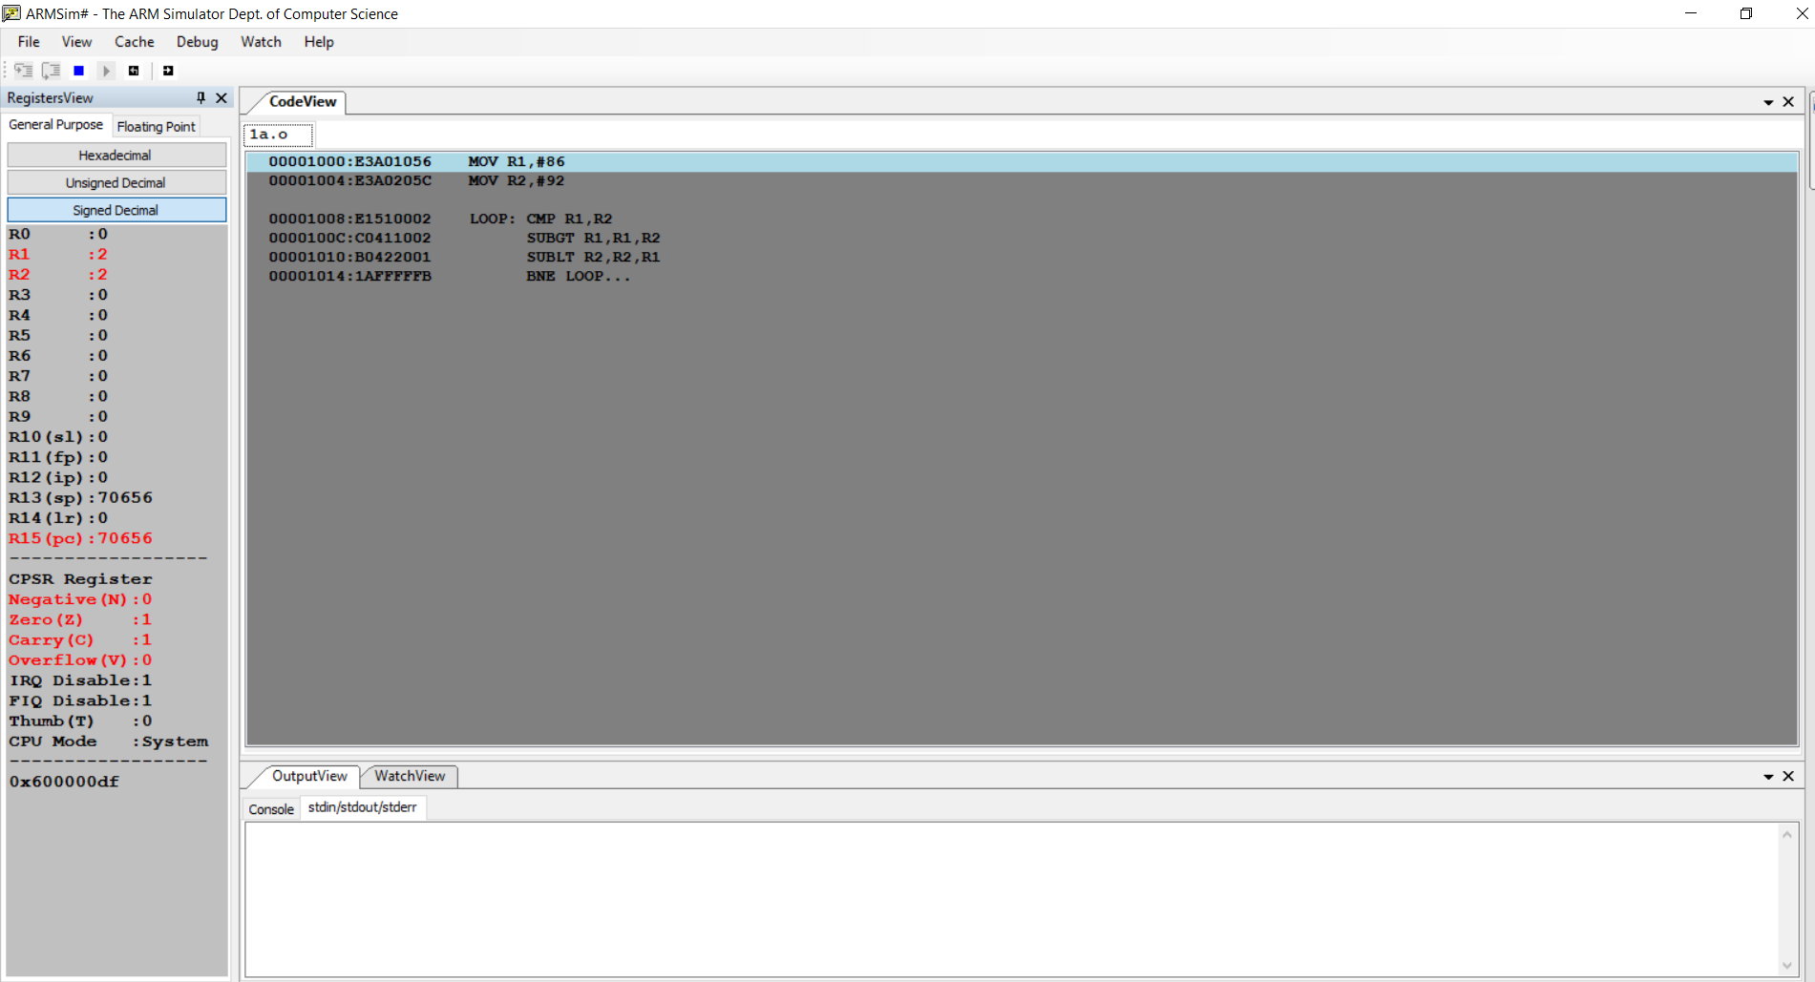**ii)**

**MOV R1,#86**

**MOV R2,#93**

**LOOP: CMP R1,R2**

**SUBGT R1,R1,R2**

**SUBLT R2,R2,R1**

**BNE LOOP**

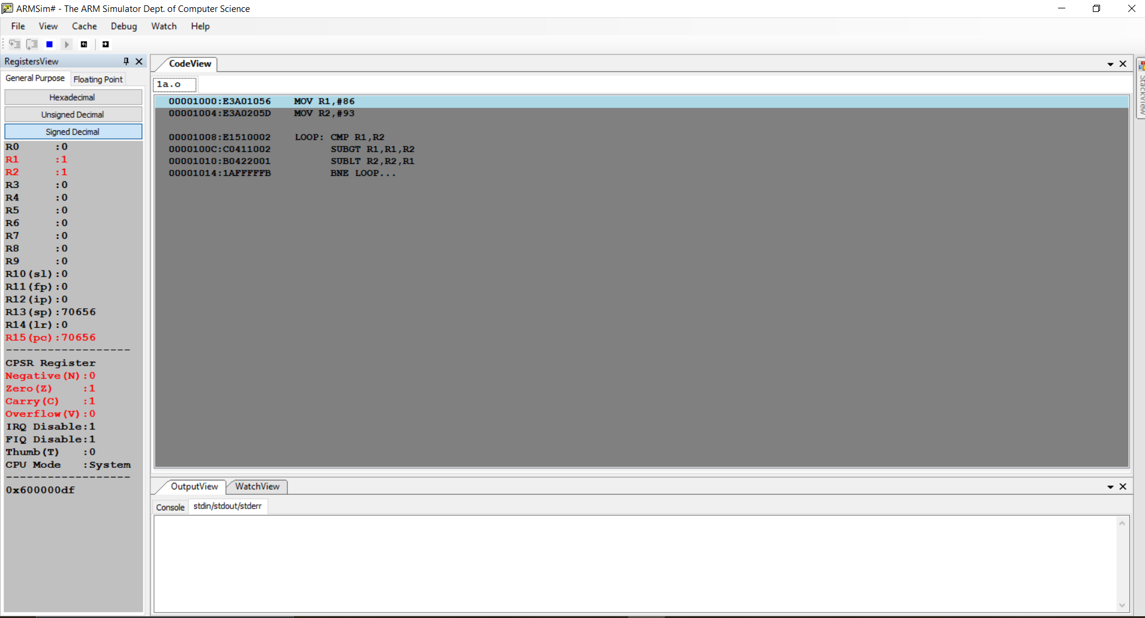

**b. Assume operands in the memory locations.**

**i)**

**.DATA**

**A: .WORD 8,7**

**GCD: .WORD 0**

**.TEXT**

**LDR R0,=A**

**LDR R3,[R0]**

**ADD R0,R0,#4**

**LDR R4,[R0]**

**LDR R1,=GCD**

**LOOP: CMP R3,R4**

**SUBGT R3,R3,R4**

**SUBLT R4,R4,R3**

**BNE LOOP**

**STR R3,[R1]**

**SWI 0X011**

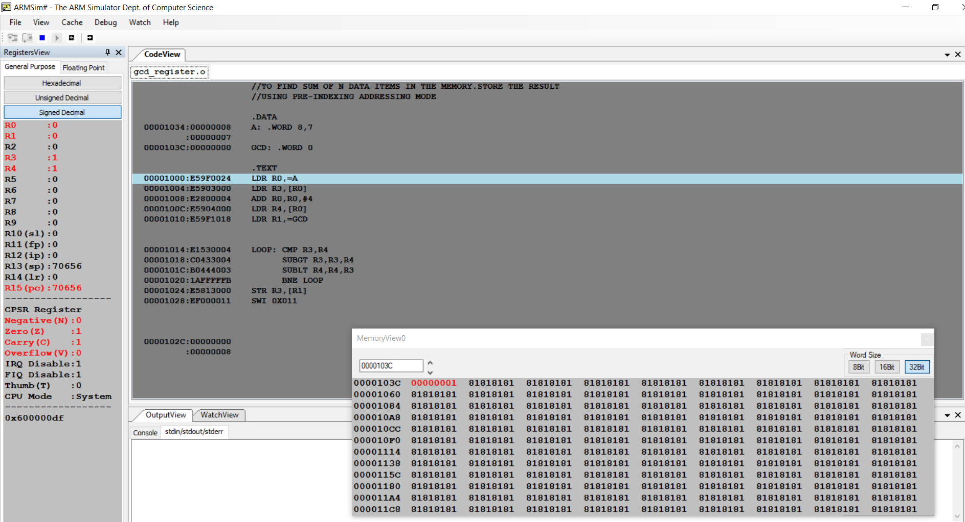

**ii)**

**.DATA**

**A: .WORD 8,7**

**GCD: .WORD 0**

**.TEXT**

**LDR R0,=A**

**LDR R3,[R0]**

**ADD R0,R0,#4**

**LDR R4,[R0]**

**LDR R1,=GCD**

**LOOP: CMP R3,R4**

**SUBGT R3,R3,R4**

**SUBLT R4,R4,R3**

**BNE LOOP**

**STR R3,[R1]**

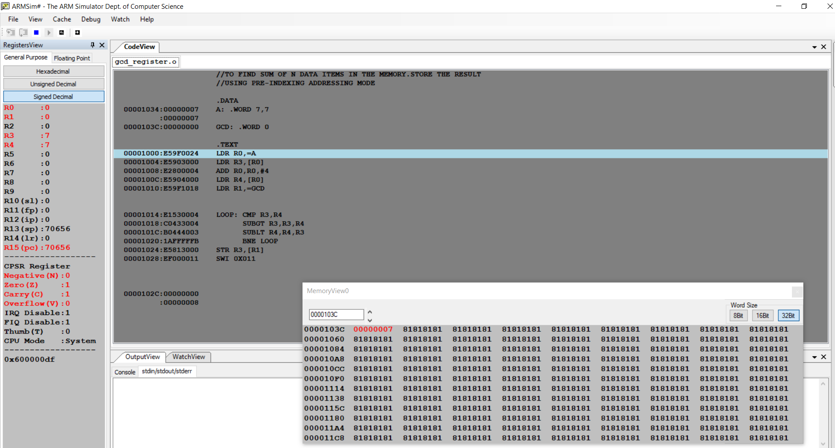**SWI 0X011**

**Microprocessor and Computer Architecture**

**UE20CS252**

**4th Semester, Academic Year 2021-22**

Date: 07/02/2022

|  |  |  |
| --- | --- | --- |
| Name: VISHWAS M | SRN:  PES2UG20CS390 | Section: F |

Week#____4_______ Program Number: ____2___

Title of the Program

**Write a program in ARM7TDMI-ISA to find the sum of N data items at alternate [ odd or even positions] locations in the memory. Store the result in the memory location.**

1. **Use Pre-indexing addressing mode**

**i)For odd indices:**

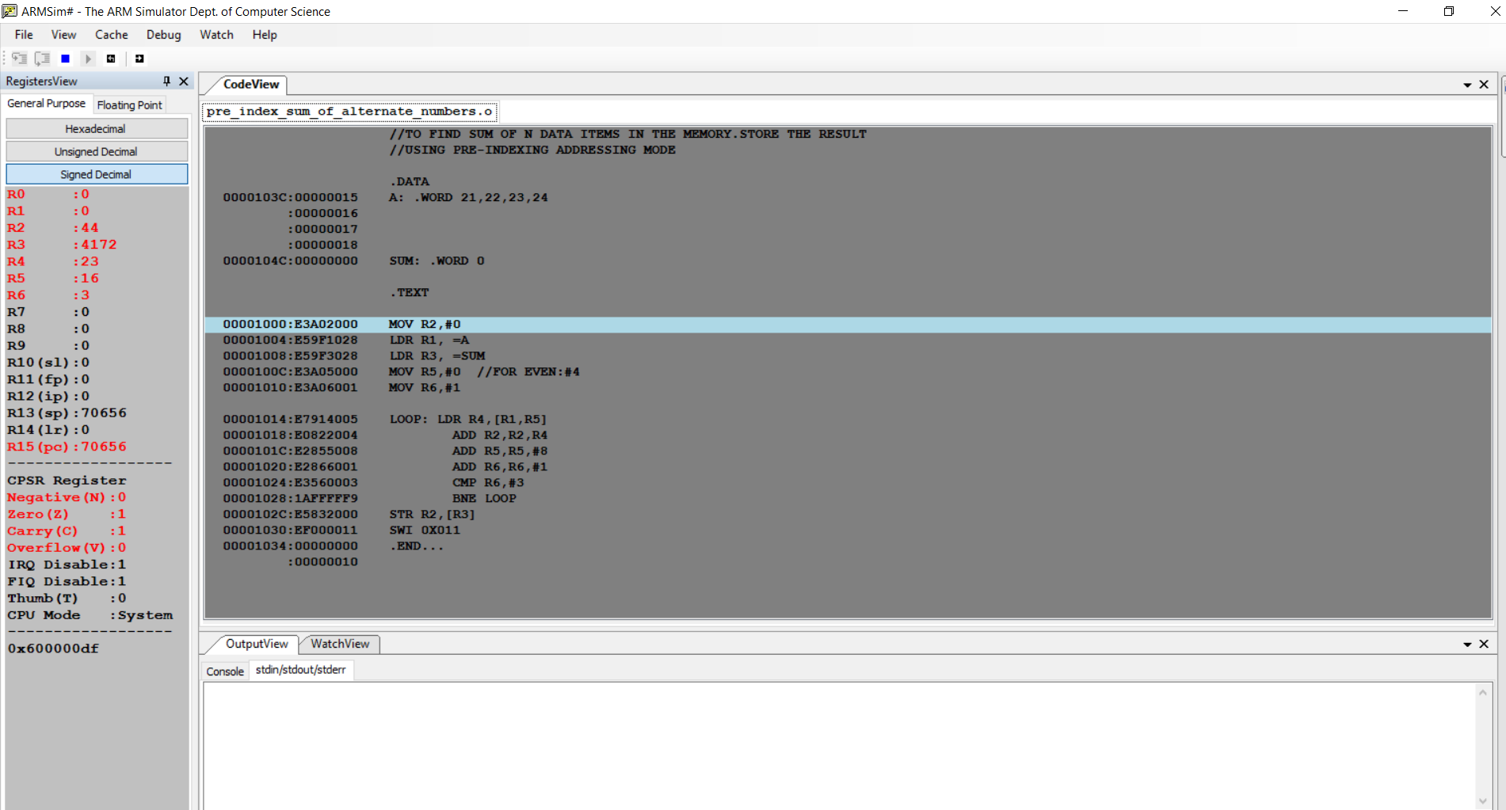

**ii)For even indexes:**

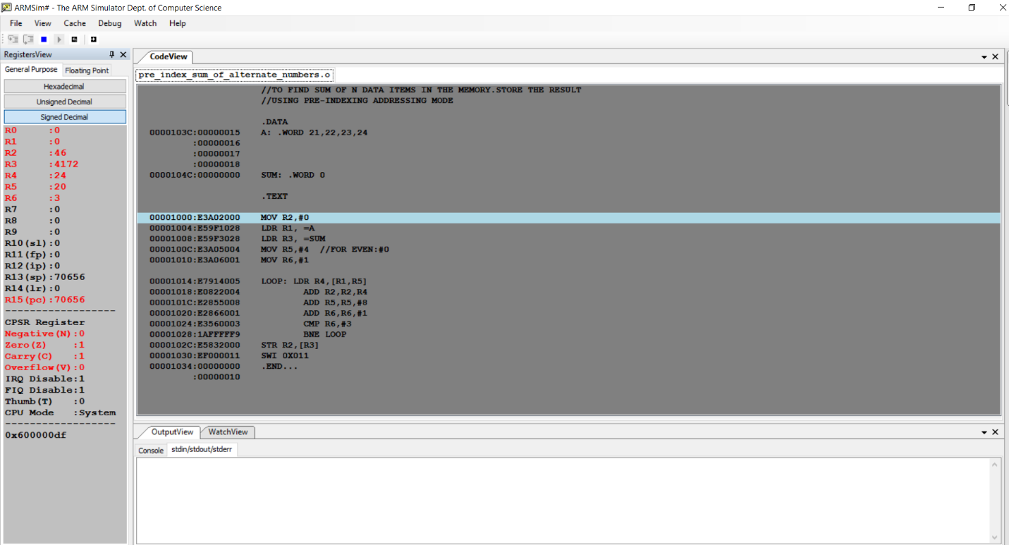

**b. Use Post- Indexing addressing mode**

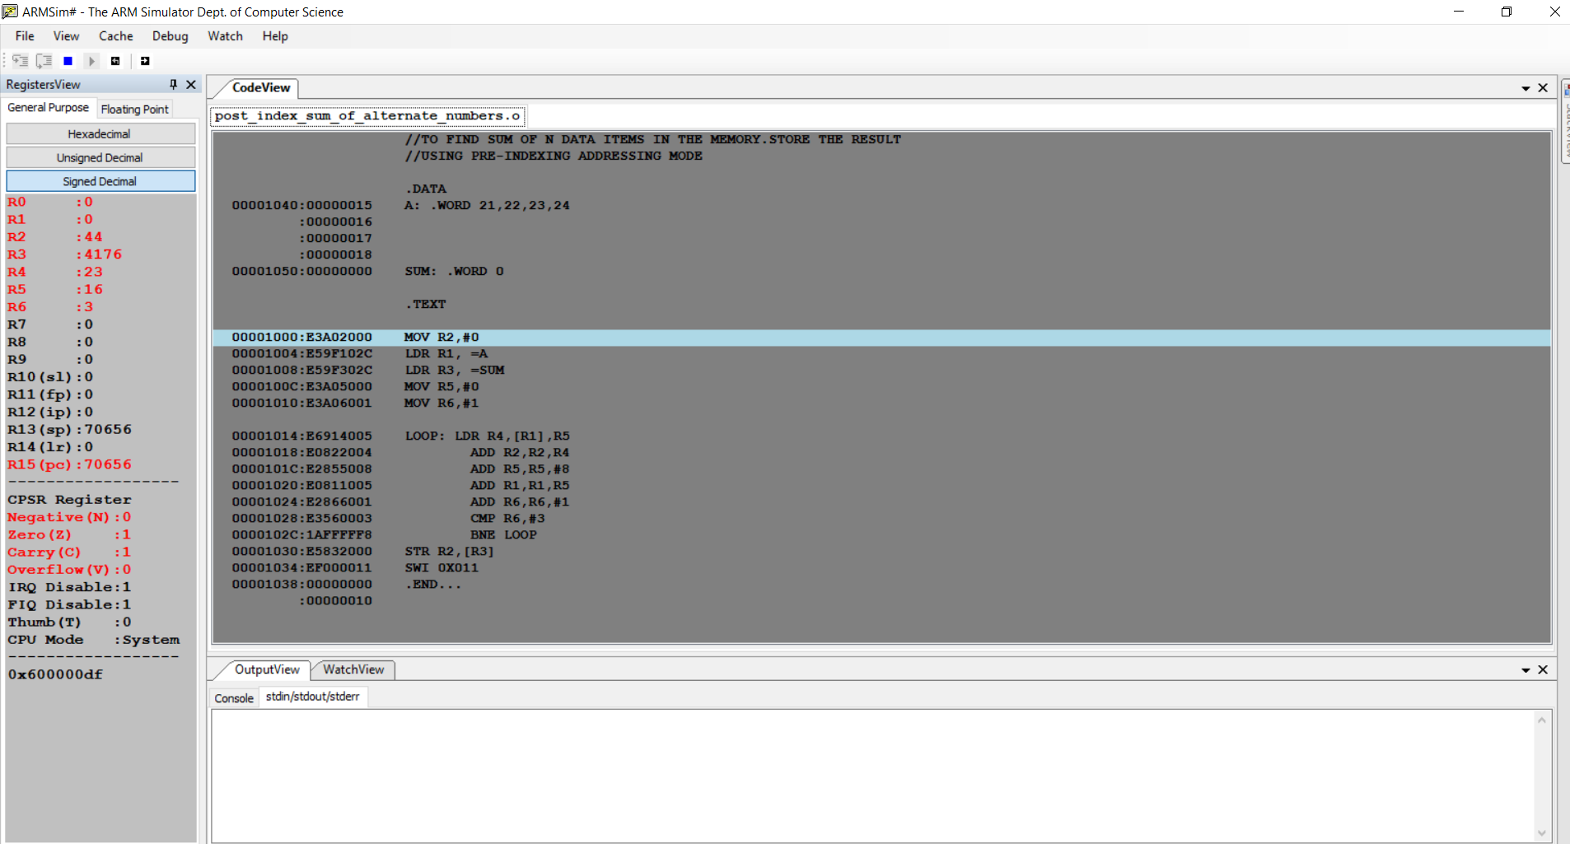**i)For odd indices:**

**ii)For even indices:**

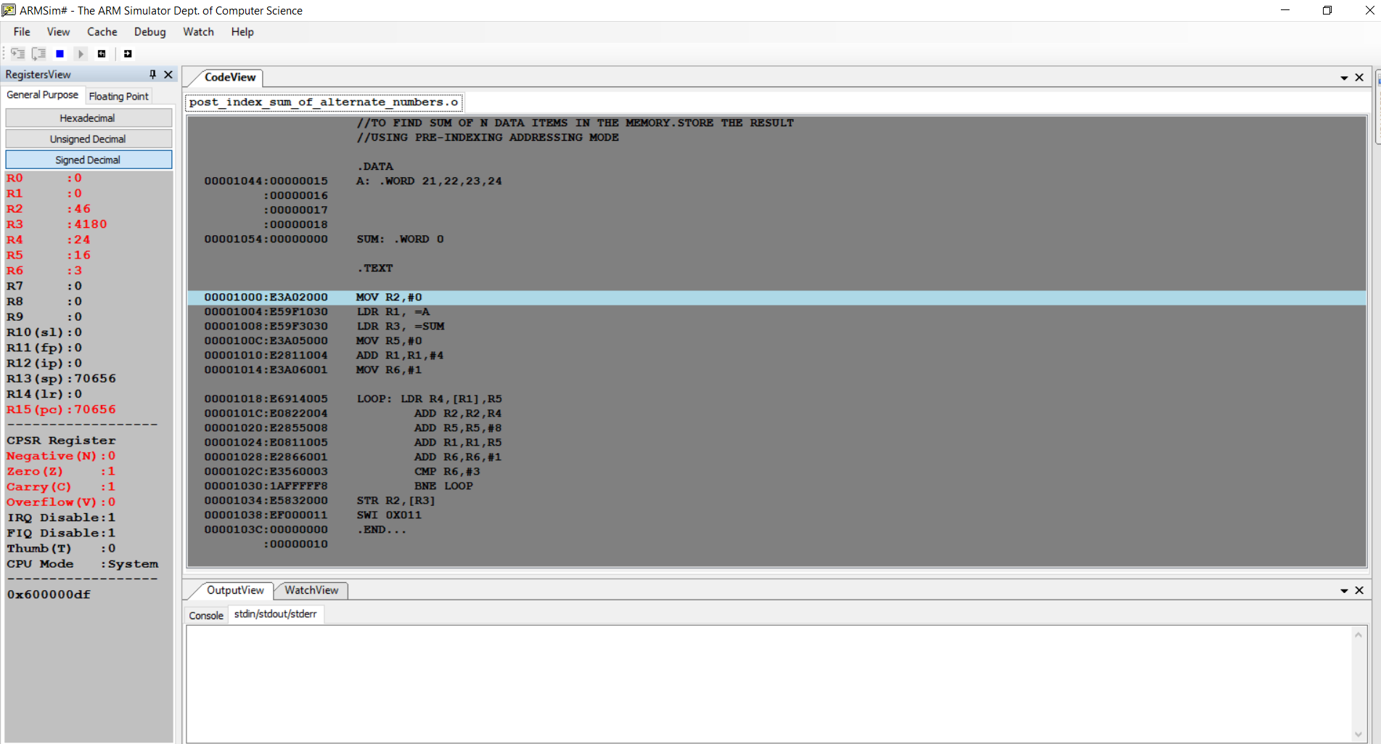

**Disclaimer:**

* The programs and output submitted is duly written, verified and executed by me.
* I have not copied from any of my peers nor from the external resource such as internet.
* If found plagiarized, I will abide with the disciplinary action of the University.

Name: VISHWAS M

SRN: PES2UG20CS390

Section: F

Date: 07/02/2022